**Ideation Phase**

**Define the Problem Statements**

|  |  |
| --- | --- |
| Date | 25 May 2025 |
| Team ID | LTVIP2025TMID49212 |
| Project Name | Cosmetic Insights : Navigating Cosmetics Trends and Consumer Insights with Tableau |
| Maximum Marks | 2 Marks |

**Customer Problem Statement Template:**

Create a problem statement to understand your customer's point of view. The Customer Problem Statement template helps you focus on what matters to create experiences people will love.

A well-articulated customer problem statement allows you and your team to find the ideal solution for the challenges your customers face. Throughout the process, you’ll also be able to empathize with your customers, which helps you better understand how they perceive your product or service.

Reference: <https://miro.com/templates/customer-problem-statement/>

|  |  |  |  |  |  |
| --- | --- | --- | --- | --- | --- |
| Problem Statement (PS) | I am (Customer) | I’m trying to | But | Because | Which makes me feel |
| PS-1 | a cosmetics brand strategist or marketing analyst | understand and respond to changes in consumer preferences | I lack timely, visual insights into real-time consumer behavior shifts | data from various sources is not unified and lacks clarity | slow to adapt and unsure about strategic decisions |
| PS-2 | a product quality and safety manager in a cosmetics company | monitor and respond to widespread product concerns or negative reviews | feedback is spread across different platforms and not easy to evaluate quickly | there’s no centralized system to analyze consumer sentiment and product issues | vulnerable to reputation damage and delayed crisis response |

**Example:**

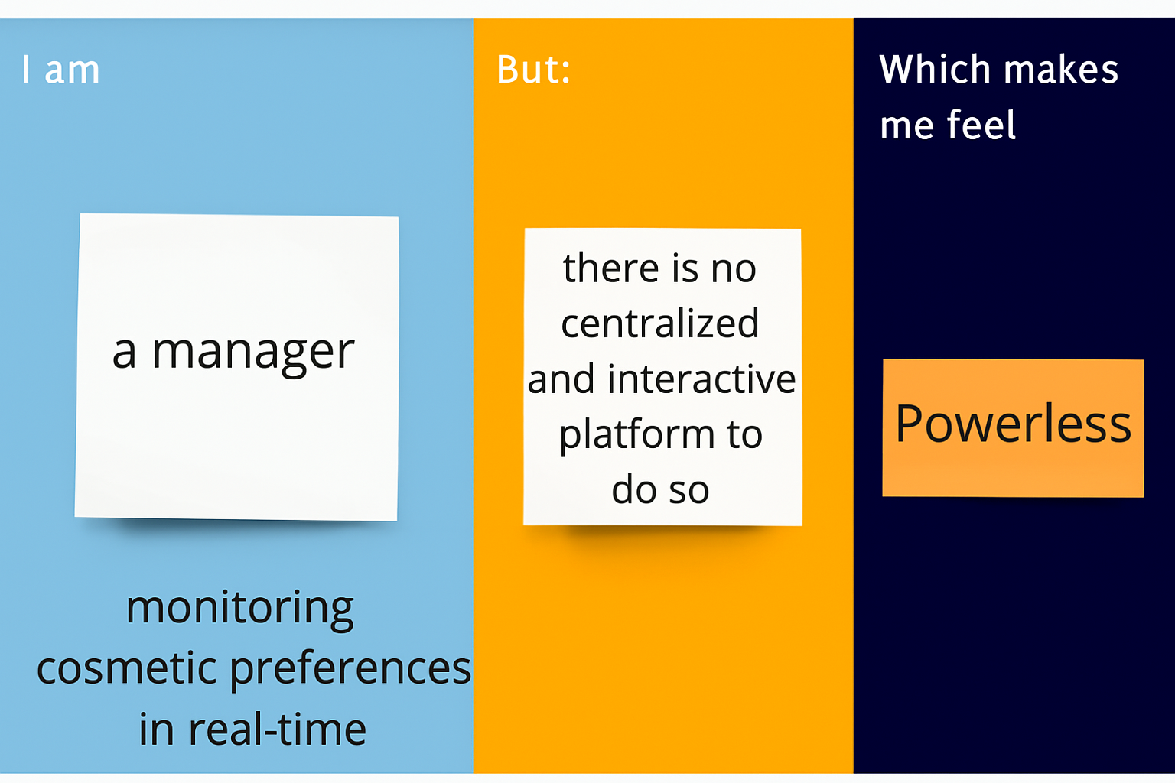

2.2 EMpathy map

